FIRST Computer Science Week Coding Activity
Team Name: __________________________________________________

Team

STEMMIE the robot has blasted off to Planet X! STEMMIE’s purpose is to determine if the planet is safe for us humans to create a new civilization.
The first step is to write the steps it will take to navigate the spaceship from Earth the Planet X. Think Creatively! What sort of actions does a spaceship need to take as it leaves our atmosphere, travels through space and safely lands on another planet?

STEP 1 |  | STEP 6
STEP 2 |  | STEP 7
STEP 3 |  | STEP 8
STEP 4 |  | STEP 9
STEP 5 |  | STEP 10

Were you able to get the ship to Planet X in 10 steps? Why or why not?

If you had more than just 10 steps what would you be able to do differently?

Great job, we made it!
STEMMIE must now navigate around Planet X to determine if it is a dangerous place and hostile to humans. You sent me outside the ship to set up a force field to protect them. Setting up the force field requires that I place a force field projector at the front and back of the ship.

Oh no! STEMMIE is trapped!
Something has fallen on top of it, and it cannot move! You must use the back up humanoid robotic power suit to rescue STEMMIE.
I can only be programmed by a simple pseudocode sent from Earth.
You and your partner will have to write the code to save STEMMIE. Once the code is written, one partner will retrieve STEMMIE, while another one calls out the code to the partner in the suit. The partner in the suit may only move according to the other partner’s instructions.

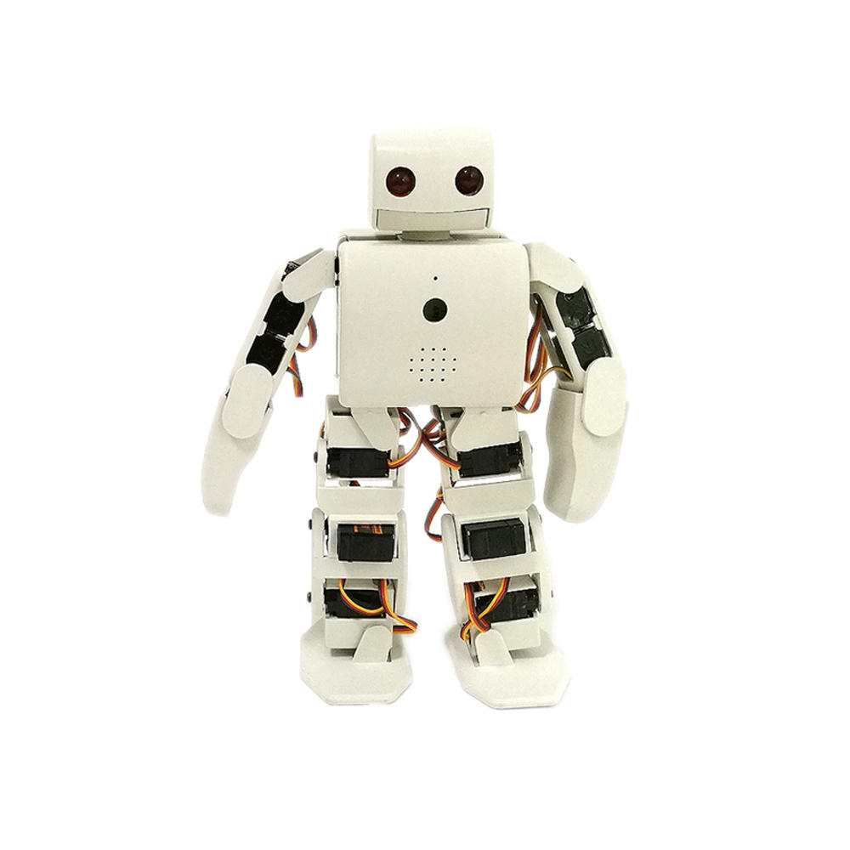

Course Layout

Using basic symbols, you will write code for the Robotic Power Suit to follow in order to free STEMMIE. For this activity a partner will imagine themselves inside the Robotic Power Suit. This person will receive the code to complete the task. The only symbols allowed to complete the task are listed below:

STEMMIE
Start

Move forward 1 square

Move backward 1 square

Turn 90º to the right

Turn 90º to the left

Pick up the box

Put the box down

Repeat previous step

Use the following space to write your code. Remember to use the symbols provided above.

Thank you for saving the mission!

See your instructor for a mission debrief.

