FRC Emcee & Game Announcer REBUILT Preseason Training Call Notes, Reminders, and Season Expectations – Feb. 2026

Theme Archaeology theme is integrated into the game by recycling past game elements.

Terminology Use the official terms for field elements as found in the manual. These terms help theme the game and create consistency across events. Consult the REBUILT Cheat Sheet
- 10903 -- Rookie team starting number
- 3700+ total teams, 200 events
- 31 - # of countries competing
NOTES – Emcee and Game Announcer
- Review Emcee Training and Game Announcer Training in Resource Library
- Emcees set tone for the event, are the face of FIRST at the event. GAs are the voice of the event.
- Emcees, GAs, and all volunteers represent FIRST. Social media posts/podcasts/streaming personas and your private life are visible to the community.
- As a FIRST volunteer, no Influencer names or online presence audience building is allowed. FIRST events are not a platform for you; they’re about supporting and spotlighting the students and teams.
- Costume/Shirt – only FIRST affiliated shirts or Sponsors. No licensed characters. Nothing provocative. If you have to ask, don’t wear it.
- Be very careful speaking around microphones and assume they are ON, especially handhelds.
- Emcees- DO NOT read verbatim from the script. Use notecards to bullet point the script contents.
- Find inclusive words to welcome and address the audience, such as “Hello Cleveland”, “Welcome Robot Fans”, “Good morning everyone and welcome…” etc. and avoid using “Ladies and Gentlemen”.
- Use full names in Ceremonies: “FIRST AGE presented by Qualcomm” and “REBUILT presented by Haas”
- During Opening Ceremonies, after introducing a guest speaker, Emcees should be accessible to the Event Mgr. and stand along the rail by the scoring table while the guest is speaking
- National Anthems: at events with 4+ nations, the suggested multi-nation procedure (and what we do at the Championship) is acknowledge all countries attending by having the Emcee announce them, and then say "Please stand, if able, and remove your hat for the national anthem of the host country". It is not expected that all anthems will be played, but the decision is up to the Event Mgr. and PDP (Program Delivery Partner).
- No Emcee Assistants- teams bring flags to field, then Emcees hand off to field re-setters to return to teams
- You need to bring your own device (computer/tablet) to the event to use gatool or FRC Matchup. FIRST provides wifi and ethernet connections.
- 2 Webcast cameras are hip/butt/crotch height and located by the field. Don’t stand in front of them.
- Team Introductions- DO NOT WAIT for a green stack light to begin introducing teams - introduce teams prior to stack light turning green by working with the FTA to determine timing.
- Introduce teams in proper direction: starting at Red Alliance driver station and moving counterclockwise
- Safety first –be careful on the field.
- Prior to Match Start: Emcee must get “field is ready” thumbs up from the FTA prior to starting match
- Emcees- after introducing the 3rd Blue Alliance team, step off the field and stay by the gate to start the match. This allows the FTA to always know where you are to give the “thumbs up”
- Match Start: “Drivers behind the line, 3, 2, 1, GO!”
- Field reset - aiming for 8 min cycles
- Gameplay sightlines are good. Stay behind Scoring table. The Fuel does fly outside of the field and it is solid.
- Music- curated Playlists again this season on DJ laptops at Regionals. Districts will have to download.
- WFFA Award– signed shirt at Regl. & District CMP events
- Before the Alliance Selection, CONFIRM RANKINGS with Ranking report and gatool or FRC Matchup
- Alliance Selection- place Capt. armbands on the field before beginning selection, then use Alliance Selection script to intro the Alliance Selection video etc.
- New sponsors for Alliance Selection (WD Imagineering) and Playoff Bracket (CAT)
- Two Ushers on field to help move teams t proper spots. See Map on Alliance Selection script.
- Declining teams get a strikethrough on Display
- If a Top 8 team picks another Top 8 team use this verbiage: “Would you like to accept this invitation or would you prefer to Captain your own alliance?”
- Mention Back-Up Team check-in before the final pick. After the final pick, ALL alliances stay on field to meet with Head Ref. The Head Ref will distribute some paperwork and meet with Captains. The four back-up teams need to confirm participation with team queuing off the field. The top 2 Backup teams will have Reps field-side during Playoffs.
- Playoff Tournament- same as last year: Double Elimination format with Upper bracket and Lower bracket.
- Use Playoff script and video assets to explain Playoff bracket to the audience. Remind teams that Awards will be presented during the Playoffs between Rounds.
- Alliances that use backups can revert to the swapped-out team in a subsequent match. Alliances deliver line-up cards to the Head Ref prior to every match.
- Conduct Handshake before Finals Match 1 (see Handshake Procedure )
- Video fillers: during the Playoffs, introduce the video segment using the script. There is local discretion of how to fill this 6 -minute break, don’t have to use our videos but we strongly suggest it.
- Award scripts will be printed out by the Scorekeeper.
- Day 2 Awards are presented on the field between Rounds with the Judges lined up on the cleared field. If Award presentations don’t need the full 15 minutes and teams are ready to play, the FTA can begin staging the teams.
- The Emcee should run the Awards ceremony on the field and read the Award description and Judge’s remarks. The GA announces Team info after Emcee announces the winners Team #
- Rookie All Star awards DO NOT have to be given out. Judge’s discretion.
- Advancement to CMP process is new. Only 3 teams at US events and 4 Intl event teams will advance from each Regional event. Others advance based on points system. Districts using same points model as last year.
- Advancement will be verified by HQ before announcing. See Advancement process in Game Manual beginning on page 133.
- FIRST Impact Award video is not a required submission. If a winning team has a FIA video, begin playing it as the team enters the receiving line, then announce advancement and close with the 2026-2027 season teaser.
- Regionals will have a spare video monitor (backup for scorekeeper) on the truck- GA’s can use at scoring table
- Webcasts: all domestic (US) Regional truck routes have a webcast unit on them. Domestic truck routes that go to Canada are also covered. Mexico is not covered.
- District Events are responsible for their own streams.
- Please complete the post-event Evaluation – you’ll receive an email post-event with a link

NOTES - Game Announcer
- Use all proper game terminology – use Cheat Sheet in Resource Library
    - Hub, Bump, Trench, Fuel, Depot, Tower, Outpost
    - Referees (not Judges)
- Print out a Cheat Sheet and bring it to your events.
- One GA only per match. If more than 1 GA is assigned to the event, rotate shifts- every 10 matches for example.
- During the first team intro announce up to 3 Sponsors, on subsequent intros no Sponsors are announced
- Use gatool or FRC Matchup, whichever you are most comfortable with. Gatool has all the bells and whistles and lots of customizing for those who GA lots of events. FRC Matchup is designed to be a streamlined entry app to get less experienced announcers up and running quickly.
- Visit teams to get updated team info on Practice Day.
- Don’t GA from audience side of the field – we want the audience to have an unobstructed view of gameplay
- DO NOT speculate on fouls (for example: “I think I just saw a foul on…”)
- Explain and note Ranking points, replays, movement across the Playoff Bracket,etc.
- Audience Display Screens - will show rankings on preview screens, icons for progress during match, QR Code
- Real time scoring in effect, but there is a Referee consultation/confirmation after match for climbs etc.
- A short animation leads off score display, with the winning alliance color revealed
- Red & Yellow cards will be on Audience Display screen, but no refs going onto the field. Always announce these cards noting rule number and definition.

All documents and recorded calls are on the Emcee & GA Resources webpage. Including:
- Master of Ceremonies & Game Announcer Training presentations
- Regional & District Template Scripts, Alliance Selection Script, Awards Script, Wildcard Sample Script
- REBUILT Cheat Sheet, Playoff Bracket and Schedule
Resources
- Emcee & GA Resource Library
- FRC Matchup
- gatool
- To request access to gatool so you can update team info : https://mailchi.mp/05884400853c/gatool
- Week Zero matches
- 2026 Event Schedule and info
- 2026 REBUILT Game Manual
- 2026 Recorded Training Calls

Questions/Issues: please email me at Blair@firstinspires.org

THANK YOU for volunteering and have a great season!

Training Call Schedule
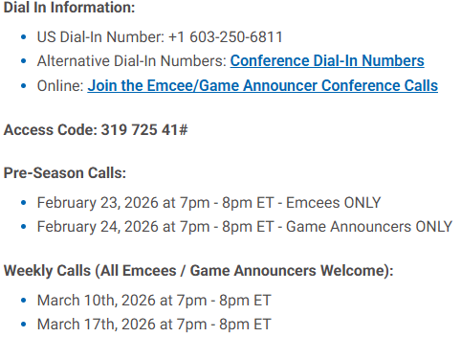

2026 Selected Rules and References
RANKING
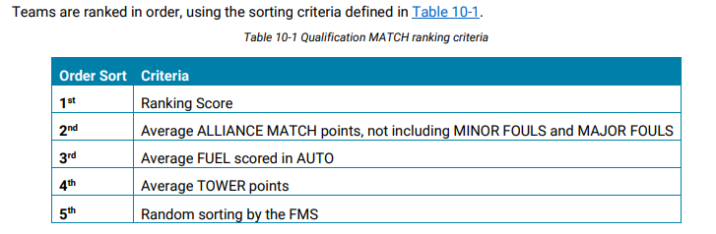

Playoff Match Schedule
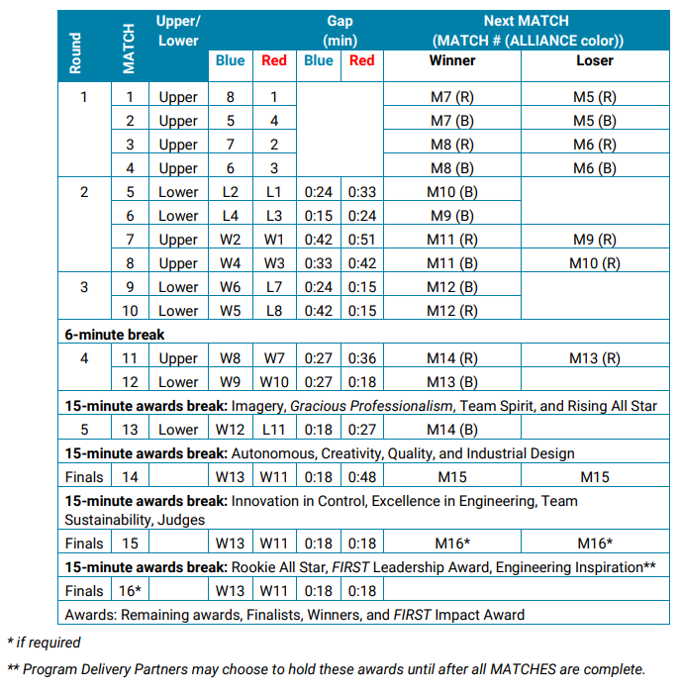
Playoff Match Ties
