Wildcard Script example 2024

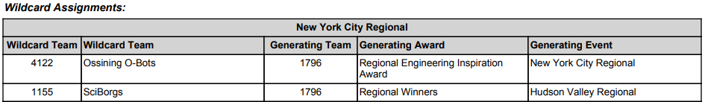

DO NOT ANNOUNCE WILDCARDS UNTIL AFTER THE FIRST IMPACT AWARD IS PRESENTED
---------------------------------------------------------------------------------------------------------------------
Wild cards are used to qualify additional teams for the FIRST Championship from Regional events.
If your team is awarded a Wildcard, please remain in your seats to be recognized.
The following Wild cards are being awarded here at the New York City Regional today. Our first Wild card was generated because of Team 1796, who won the Regional Engineering Inspiration Award here a few moments ago. This position is presented to Team 4122, Ossining O-Bots, who will be invited to the FIRST Championship!

Our second Wild card was generated because of Team 1796, who were the Regional Winners at the Hudson Valley Regional. This position is presented to Team 1155, SciBorgs, who will be invited to the FIRST Championship!

